Cairo University Faculty of Computers and Information



**Software Engineering II**

**Daily scrum meeting template**

**2020**

**Project Team**

|  |  |  |  |
| --- | --- | --- | --- |
| **ID** | **Name** | **Email** | **Mobile** |
| 20170144 | Abdelrhman hosny awad | [Body.hosny111@gmail.com](mailto:Body.hosny111@gmail.com) | 01018236359 |
| 20170145 | Abdelrhman reda fadl | [Boodycat09@gmail.com](mailto:Boodycat09@gmail.com) | 01154847004 |
| 20170443 | Mohamed wael hassan | [Mohamed606tanna@gmail.com](mailto:Mohamed606tanna@gmail.com) | 01013489981 |
| 20170125 | Seif alaa eldin | [Seifalaa143@gmail.com](mailto:Seifalaa143@gmail.com) | 01156984100 |
|  |  |  |  |
|  |  |  |  |

Contents

Instructions [To be removed] 2

Done requirements 2

What will be done today 2

Current obstacles 3

Current Trello workspace 3

# Instructions [To be removed]

* **IMPORTANT. Rename this document to CS352-LeaderID-TANAME- ScrumMeeting.docx**

**[Write TA name in your document name]**

**Examples:**

**20120001-MohamedSamir- ScrumMeeting.docx**

**20120001-OmarKhaled- ScrumMeeting.docx**

* **Remove the following notes and any red notes**

# Done requirements

**Day1 (All the team was working together):**

* **Review project description**
* **Create project git repository**
* **Create Trello board**
* **First cut class diagram**

**Day2 (All the team was working together):**

* **Discussion about the goal of the project and its boundary**
* **Understand the difference between SOAP&RESTFUL APIs**
* **first cut of sequence diagram for the first requirement in this sprint**

**Day3 (All the team was working together):**

* **first cut of sequence diagram for the second requirement**
* **fist version of class diagram for sprint 1**
* **Agreed on database schema**

**Day4**

* **Abdelrhman hosny : create database schema ,implement the project classes and second requirement**
* **Abdelrhman reda& Abdelrhman hosny : implement first requirement**

# What will be done today

* **In this section you should state what will be done by each member today**
* **Meeting with TA Mahmoed Hadad**

# Current obstacles

**Abdelrhman Reda & Abdelrhman Hosny :**

**In Insert Function , handling the query if an integer attribute was added to the users information in the future could cause a headache**

# Current Trello workspace

* **Provide screen shot for your trello workspace**
* **Your screenshot should show product backlog (current requirements) and role of each members**

**Example:**

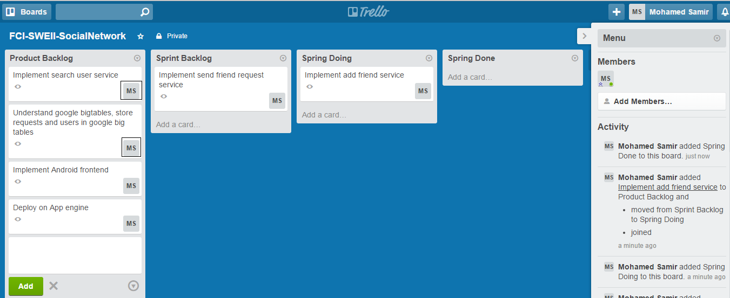

**Note black boxes which state who is responsible for each requirement**